# Banko Play Simulator - BP1B

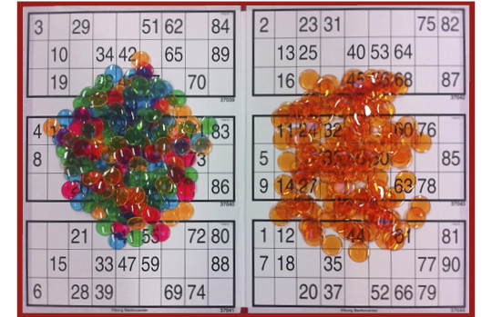Banko (and Bingo) has mo­re than 100 years of history in Denmark. Traditi­on­ally one could win food f.ex. meat or chocolate upon first row filled, up­on two rows filled and all 3 rows gave ½ pig.

Figur 1 http://www.epbanko.dk/Dækbrikker

In this exercise you must **design** and **implement** a simu­lator of a game of Banko. I.e. draw random numbers and return the ID of the banko plate(s), who first fill a row, two rows and the full plate with 3 rows.

NOTE :

that the twin~exercise BankoPlateGenerator_BP1A must deliver the plates (at least 50) for your game. So your input must adherer to the agreement with the other development team.

Remember :

one class ~ one responsibility

EXERCISE 1

Design the Banko Play Simulator (see the rules below) using the neces­sary and known UML tools.

During this design phase plan together with the development team of Exercise BP1A the format of the generated Banko Plates, so they can be used in your code. The result of this must be a written description – a contract.

EXERCISE 2

Implement the code according to your own design and to your agreement with the other development team.

Remember to implement equals() and toString().

EXERCISE 3

Test it !!!

RULES FOR BANKO PLAY

Every produced Banko Plate has its own unique number for identification.

The basis plate has 3 rows and 9 columns (see below) with 15 different random numbers from either of the intervals

[ 1 – 89 ] or [ 1 – 90] (your choice)

Each set of numbers on the Banko Plate must be unique too.

When the game begins everyone has empty plates.

The Caller randomly draws a number and tells it loud and clear. Every player, with that number on a plate(s), cover the number with a plastic chip.

The Caller draws a new number and continues to repeat that until one (or eventually more) player(s) claim “BANKO” for the first row filled (the 5 numbers are covered).

The plate unique number is checked and the player receives the prize.

The Caller continues until a player claims “BANKO” for two filled rows. The number is checked, prize given and the game continues with the third and last round, where the claim “BANKO” means a completed plate i.e. all 3 rows are covered. The prize here is usually much larger than the previous two.